**＋Second Reading** ---------------------1 Corinthians 12:31–13:8a

　Read by Groom Mother Maria ○○○○○

　　　　　　　　　　　　　　　*

Brothers and sisters: Strive eagerly for the greatest spiritual gifts.But I shall show you a still more excellent way.If I speak in human and angelic tonguesbut do not have love,I am a resounding gong or a clashing cymbal.

And if I have the gift of prophecyand comprehend all mysteries and all knowledge; if I have all faith so as to move mountains, but do not have love, I am nothing. If I give away everything I own, and if I hand my body over so that I may boast but do not have love, I gain nothing.

Love is patient, love is kind.

It is not jealous, is not pompous,  
it is not inflated, it is not rude,  
it does not seek its own interests,  
it is not quick-tempered, it does not brood over injury, it does not rejoice over wrongdoing but rejoices with the truth.  
It bears all things, believes all things,  
hopes all things, endures all things.Love never fails.

**The word of the Lord.**

3

*(Stand up please*)

♪**Gospel Acclamation**♪　 Celtic Alleluia

*(Please everyone sing together)*

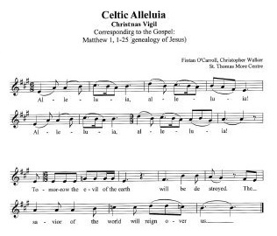

4