**＋Gospel Reading and Homily**------------------Matthew 5:1-12a

Fr. ○○○○○. Pastor St. ○○○○ Church

Fr : The Lord be with you / Our : **And also with you.**

Fr : The reading from the Holy Gospel according to･･

Our：**Glory to you, Lord +++**

*

When Jesus saw the crowds, he went up the mountain,  
and after he had sat down, his disciples came to him.  
He began to teach them, saying:  
“Blessed are the poor in spirit,  
for theirs is the Kingdom of heaven.  
Blessed are they who mourn,  
for they will be comforted.  
Blessed are the meek,  
for they will inherit the land.  
Blessed are they who hunger and thirst for righteousness,  
for they will be satisfied.  
Blessed are the merciful,  
for they will be shown mercy.  
Blessed are the clean of heart,  
for they will see God.  
Blessed are the peacemakers,  
for they will be called children of God.  
Rejoice and be glad,  
for your reward will be great in heaven.”  
**The Gospel of the Lord.**

**Our: Praise to you, Lord Jesus Christ**.

　　　　　　　　　　　　　　5

**RITE OF MARRIAGE**

（A bride and groom and a witness stand up, and please go out to the front.）

**Address to Bride & Groom**

**Questions before Consent**

Fr.○○○○○

"○○○○ and ○○○○, have you come here to enter into Marriage without coercion, freely and wholeheartedly?

○○&○○ I have.

Fr.○○○○ "Are you prepared, as you follow the path of Marriage, to love and honor each other for as long as you both shall live?

○○&○○ I am.

Fr.○○○○○   
"Are you prepared to accept children lovingly from God and to bring them up according to the law of Christ and his Church?"

○○&○○ I am.

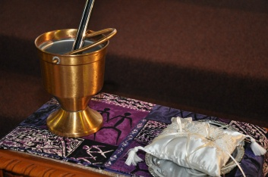

６